Name of the Student: G. Manasa Goud | Academic Year: 2025-26
Student Registration Number: 241U1R3007 | Year & Term: II & II
Study Level: UG | Class & Section: CSE(DS)-2A
Name of the Course: FOUNDATION OF DATA SCIENCE | Name of the Instructor: Mr. Pranay Vemula, Assistant Professor, CSE.
Name of the Assessment: Reflective Journal 6 | Date of Submission: 23-11-2025

Journal Entry Topic | Module - VI: Model Evaluation  Evaluation metrics types, Training vs. validation vs. testing, Regression Model Evaluation Metrics, Classification Model Evaluation Metrics, Clustering Metrics, Cross-Validation, Overfitting and underfitting.
- Experience  (Class Content) | In this module I learned about model evaluation it is the process of different evaluation metrics and we learned about classification model evaluation metrics in that we have accuracy, precision, recall (sensitivity, true positive rate), E1 score, AUC, Confusion Matrix and next we discussed about Regression Model Evaluation Metrics in that we discussed about Mean Absolute error, Mean Squared error, Root mean Squared error, R-squared. Next sir talked about clustering Metrices in that we discussed about Silhouette Score, Davies-Bouldin Index, Calinski - Harabasz Index (Variance Ratio Criterion), Adjusted Rand Index (ARI), Mutual Information (MI). and later we discussed about Training vs Testing vs Validation at last we learned about cross Validation there are types of cross validation . Holdout Validation, LOOCV (Leave One Out Cross Validation), Stratified Cross-Validation, K-Fold Cross Validation. At last we discussed about overfitting and underfitting.
2. Feelings  (Emotional Reactions) | After learning this module, I feel happy because I finally understand how to check if a machine learning model is good or not. The evaluation metrics, cross-validation methods, and the ideas of overfitting and underfitting made things clearer for me. At first it felt a little confusing, but now I feel more confident and interested in learning more about machine learning.
3. Learning  (Key Insights) | 1.Model Evaluation:  Model evaluation is the process of using different evaluation metrics to understand a machine learning model’s performance, as well as its strengths and weaknesses.  2.Classification Model Evaluation Metrics :  - Accuracy: Accuracy simply measures how often the classifier correctly predicts.  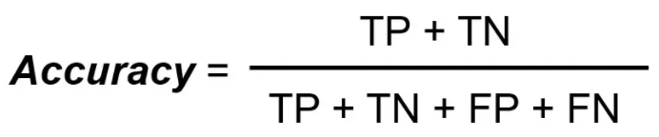  - Precision: Precision is useful in the cases where False Positive is a higher concern than False Negatives.  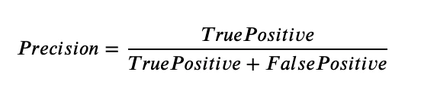  - Recall (Sensitivity, True Positive Rate): Recall is a useful metric in cases where False Negative is of higher concern than False Positive.  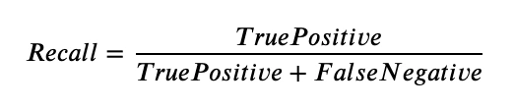  - F1 Score : F1 Score is the harmonic mean of precision and recall.  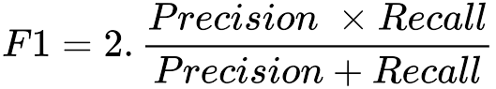  - AUC: The Area Under the Curve (AUC) is the measure of the ability of a classifier to distinguish between classes.  - Confusion Matrix: The confusion matrix is a table used to evaluate the performance of a classification model by comparing the predicted and actual values. It consists of four components:  There are 4 terms you should keep in mind:  - True Positives: It is the case where we predicted Yes and the real output was also yes.  - True Negatives: It is the case where we predicted No and the real output was also No.  - False Positives: It is the case where we predicted Yes but it was actually No.  - False Negatives: It is the case where we predicted No but it was actually Yes.  3. Regression Model Evaluation Metrics :  - Mean Absolute Error (MAE): It is the average distance between Predicted and original values.  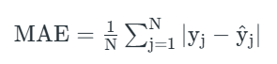  - Mean Squared Error (MSE): It is similar to mean absolute error but the difference is it takes the square of the average of between predicted and original values.  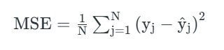  - Root Mean Squared Error (RMSE): We can say that RMSE is a metric that can be obtained by just taking the square root of the MSE value.  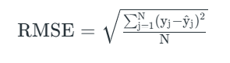  - R-squared (R²): It is the amount of variation in the output-dependent attribute which is predictable from the input independent variable(s).  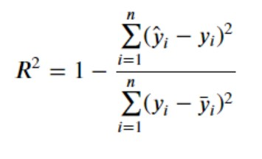  4.Clustering Evaluation Metrics :  - Silhouette Score: The Silhouette Score evaluates how well a data point fits within its assigned cluster compared to others.  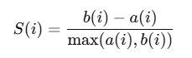  - Davies-Bouldin Index: The Davies-Bouldin Index evaluates clustering quality by assessing:  - Cluster Compactness: How tightly the points in a cluster are grouped around the centroid.  - Cluster Separation: How distinct or well-separated different clusters are from each other.  - A lower DB Index indicates better clustering, with more compact and well-separated clusters.  - Calinski - Harabasz Index (Variance Ratio Criterion): The Calinski-Harabasz Index evaluates clustering quality by measuring:  - Cluster Compactness: How tightly clustered data points are within clusters.  - Cluster Separation: How well-separated different clusters are from one another.  - A higher Calinski-Harabasz Index indicates better clustering, with compact clusters that are well-separated.  - Adjusted Rand Index (ARI): The Adjusted Rand Index (ARI) is a measure of the similarity between two data clusterings.  - Mutual Information (MI): Mutual Information (MI) is a statistical measure that quantifies the amount of information shared between two random variables  5.Cross-Validation: Cross validation is a technique used in machine learning to evaluate the performance of a model on unseen data.  Types of Cross Validation:  - Holdout Validation: Holdout Validation is a method where the dataset is split into two parts:  - Training set – used to train the model  - Test set – used to evaluate the model  This checks how well the model works on unseen data.  Example split: 70% training, 30% testing.  - LOOCV (Leave One Out Cross Validation): In LOOCV, only one sample from the dataset is used as the test set and all the remaining samples are used for training.  This process repeats for every sample in the dataset.  3. Stratified Cross-Validation: Stratified Cross-Validation ensures that each fold of the dataset has the same class proportions as the original dataset.  It is mainly used for classification problems where classes must be balanced.  4 . K-Fold Cross Validation: In K-Fold Cross Validation, the dataset is divided into K equal parts (folds).  The model is trained on K-1 folds and tested on the remaining 1 fold.  This process repeats K times, and the final performance is the average of all runs.  Example: K = 5 (5-fold cross validation).  Overfitting :  A statistical model is said to be overfitted when the model does not make accurate predictions on testing data.  Underfitting:  A statistical model or a machine learning algorithm is said to have underfitting when a model is too simple to capture data complexities.
$$4. Application$$  $$(Practical Use)$$ | 1. Evaluation Metric Types – Applications  - Used to measure model performance in real-world tasks.  - Helps compare multiple machine learning models.  - Supports model selection by choosing the best-performing metric.  - Useful in determining accuracy, error, precision, ranking, or probability-based predictions.  - Helps identify whether a model is suitable for business, healthcare, finance, or scientific use.  2. Training vs. Validation vs. Testing – Applications  - Helps divide data properly for model development.  - Training data: used to teach the model.  - Validation data: used for tuning parameters and avoiding overfitting.  - Test data: used for final performance evaluation on unseen data.  - Ensures the model works well in real-life deployment.  3. Regression Model Evaluation Metrics – Applications  (Examples: MSE, RMSE, MAE, R²)  - Helps analyze how close predictions are to real values.  - Selects the best regression model for financial, scientific, and engineering applications.  4. Classification Model Evaluation Metrics – Applications  (Examples: Accuracy, Precision, Recall, F1-Score, AUC)  - Helps understand how well the model handles imbalanced datasets.  - Important for medical diagnosis, security, and decision systems.  5. Clustering Metrics – Applications  (Examples: Silhouette Score, Davies–Bouldin Index)  - Used to evaluate unsupervised learning models.  - Helps measure the compactness and separation of clusters.  6. Cross-Validation – Applications  - Used to check model stability and generalization.  - Prevents overfitting by testing the model on multiple data splits.  - Useful when dataset is small.
5. Conclusion | In this module, I learned how to evaluate machine learning models using different metrics for classification, regression, and clustering. I understood how training, validation, and testing data are used, and how cross-validation improves model reliability. I also learned the difference between overfitting and underfitting. this module helped me understand how to check and improve a model’s performance effectively.

